Q-1. Write an SQL query to fetch “FIRST_NAME” from Worker table using the alias name as <WORKER_NAME>

Ans:---- (select FIRST_NAME from Worker as WORKER_NAME).

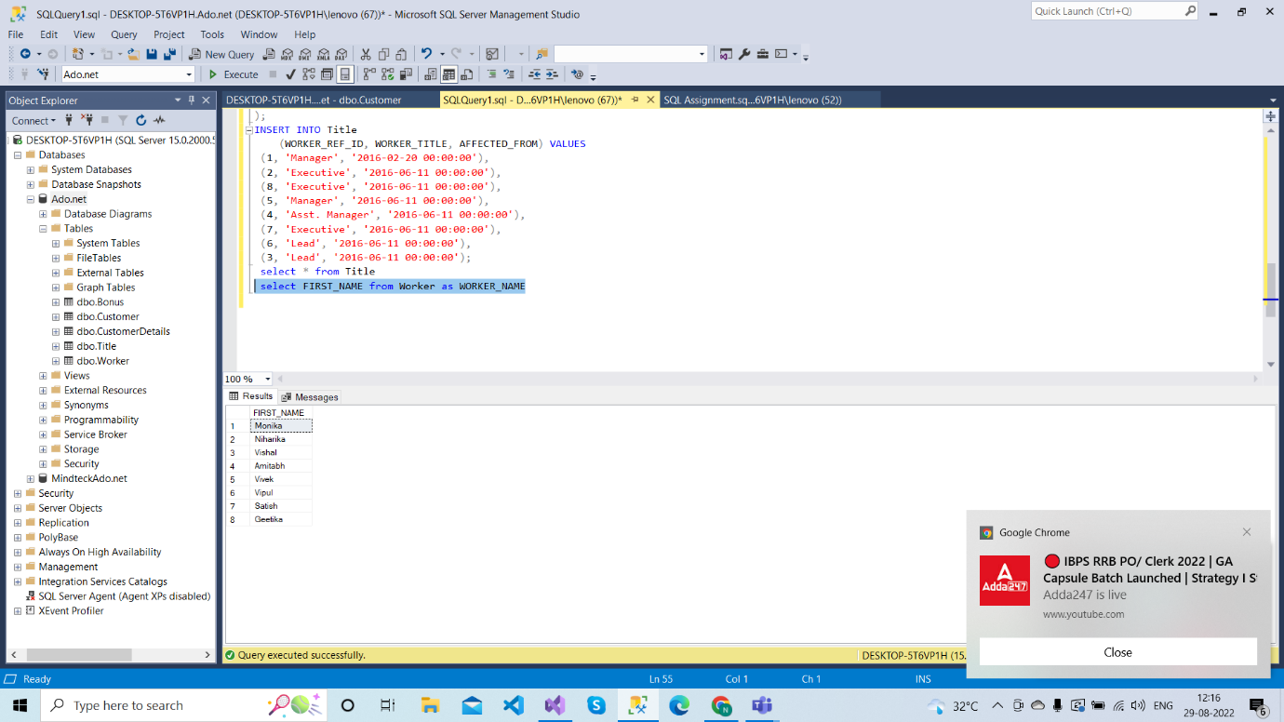

Q-2. Write an SQL query to fetch “FIRST_NAME” from Worker table in upper case.

Ans:------( SELECT UPPER(FIRST_NAME FROM Worker);

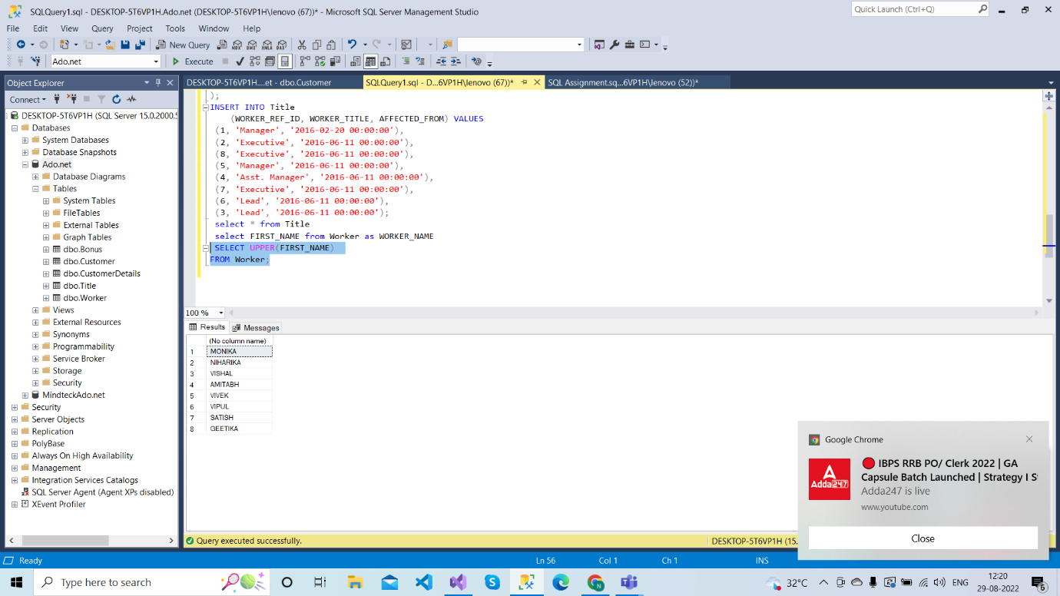

Q-3. Write an SQL query to fetch unique values of DEPARTMENT from Worker table.

Ans:------(SELECT DISTINCT DEPARTMENT FROM Worker);

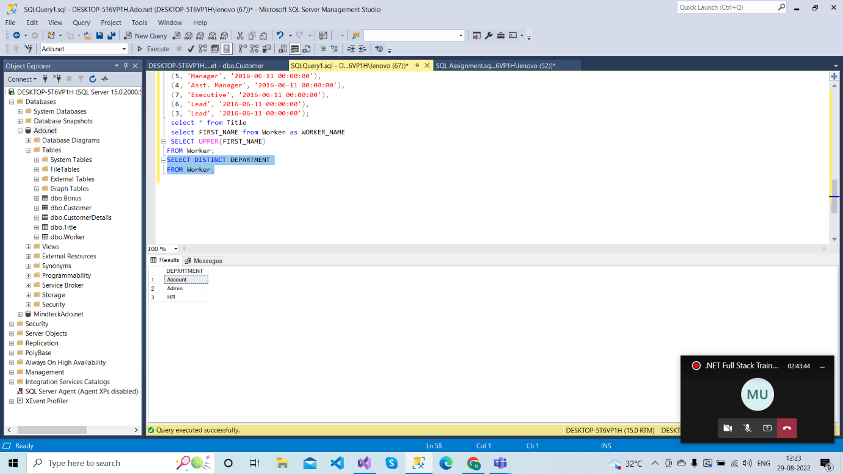

Q-4. Write an SQL query to find the position of the alphabet (‘a’) in the first name column ‘Amitabh’ from Worker table.

Ans:----Select CHARINDEX('a','Amitabh') from Worker where FIRST_NAME = 'Amitabh';

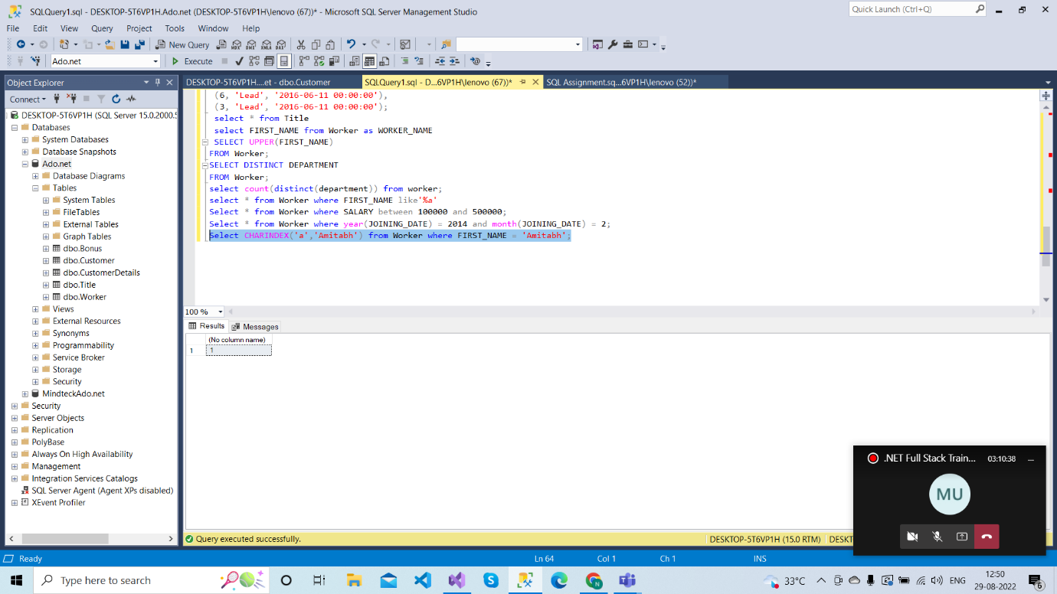

Q-5. Write an SQL query that fetches the unique values of DEPARTMENT from Worker table and prints its length.

Ans:----(select count(distinct(department)) from worker);

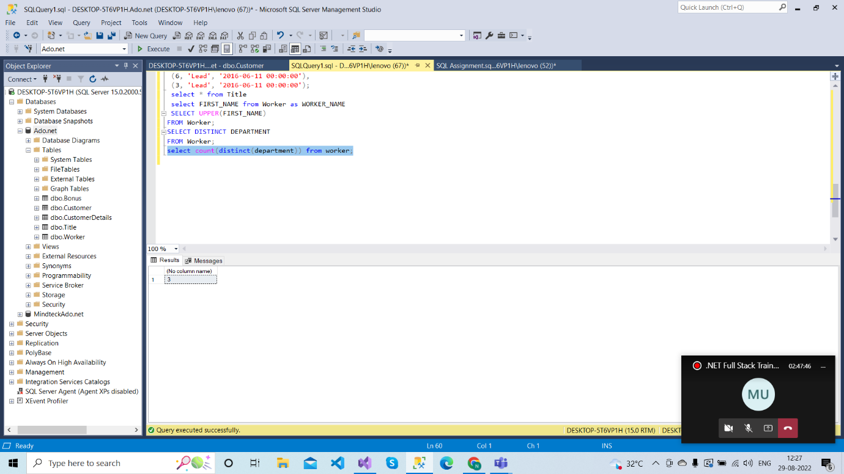

Q-6. Write an SQL query to print details of the Workers whose FIRST_NAME ends with ‘a’.

Ans:-----(select * from Worker where FIRST_NAME like'%a');

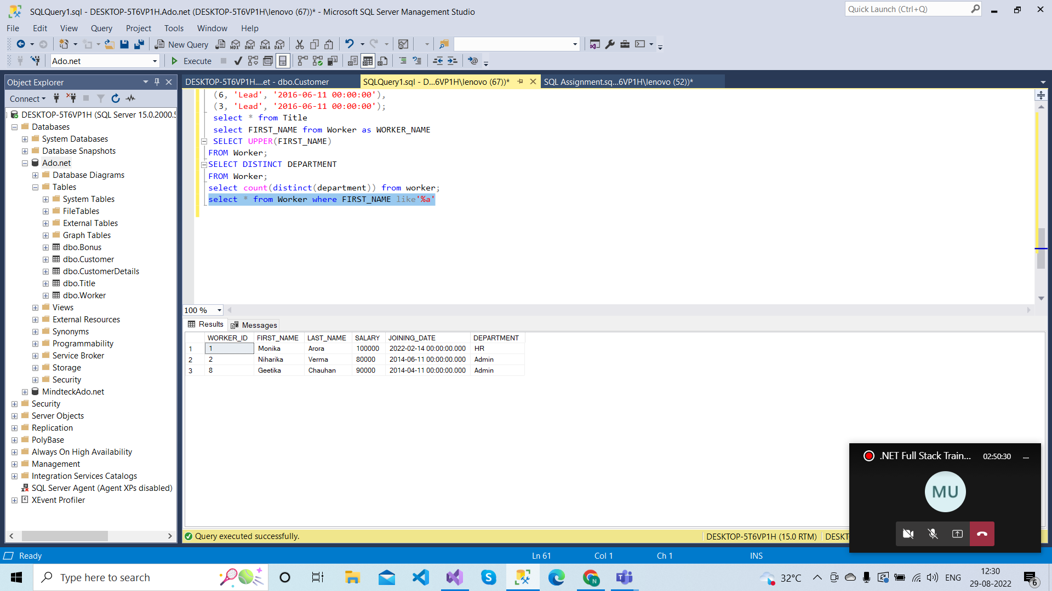

Q-7. Write an SQL query to print details of the Workers whose SALARY lies between 100000 and 500000.

Ans:----(Select * from Worker where SALARY between 100000 and 500000);

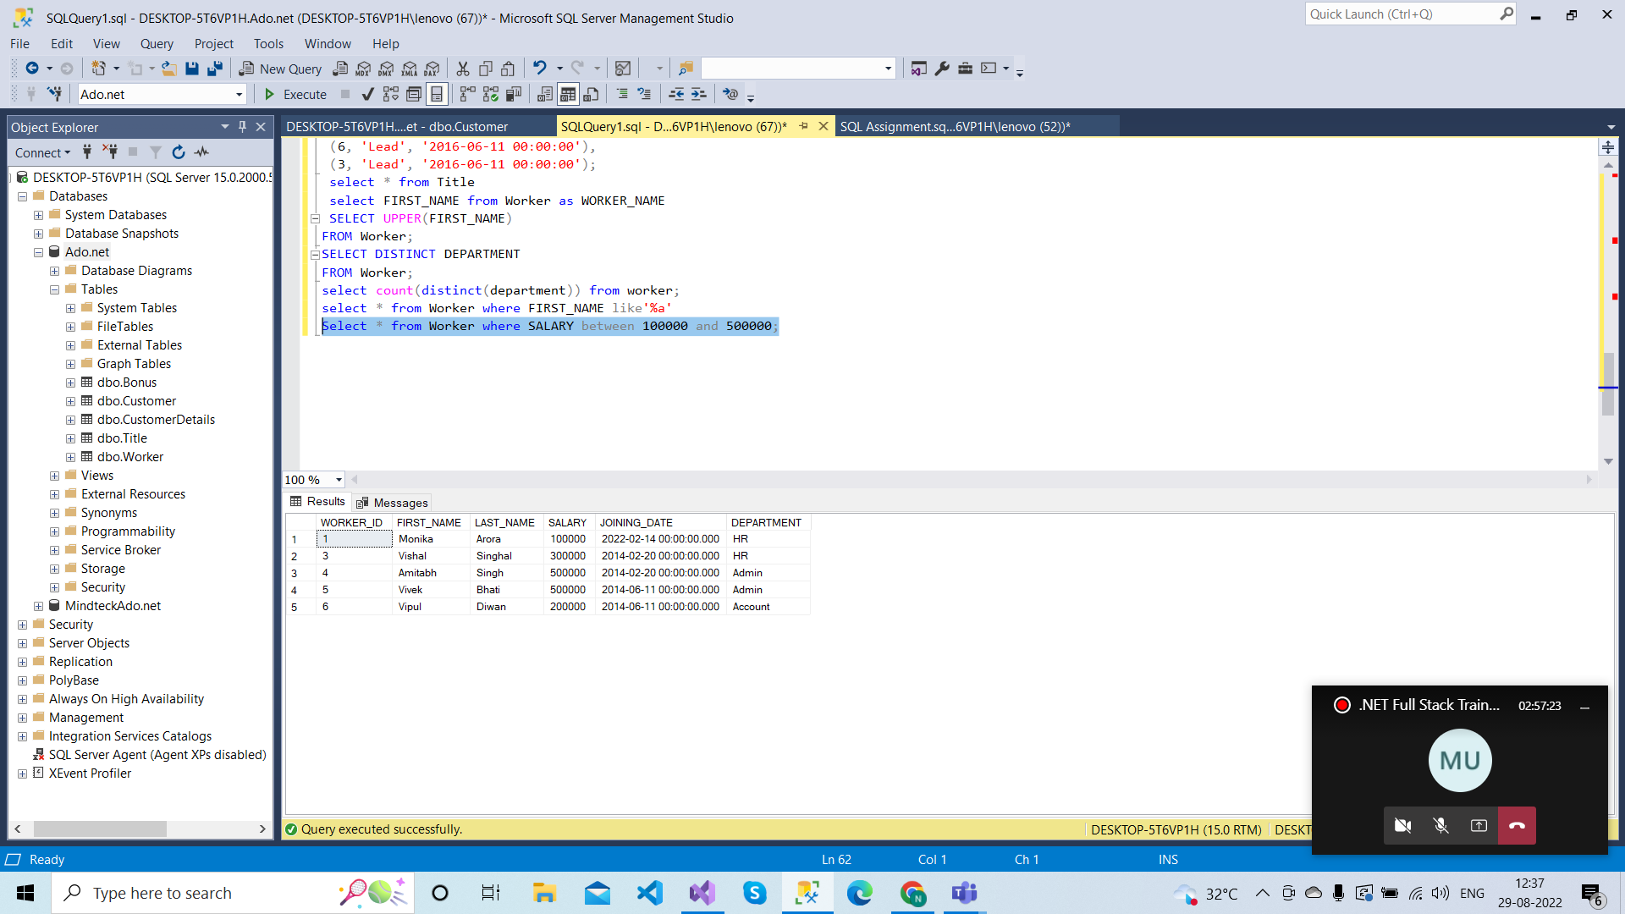

Q-8. Write an SQL query to print details of the Workers who have joined in Feb’2014.

Ans:-----Select * from Worker where year(JOINING_DATE) = 2014 and month(JOINING_DATE) = 2;

